1 Introduction 1
1.1 Purpose and Scope 1
1.2 Terminology 2
2 Interface Overview 2
2.1 Session 2
2.1.1 Example - Starting a session 2
2.2 Access Point Information Query 2
2.2.1 Example – what access points are configured on the device? 2
2.3 Access Point Change Notification 3
2.3.1 Example – when will this service become available? 3
3 Use Cases 5
3.1 Wi-fi 5
3.1.1 Initial scan 5
3.2 Bluetooth 7
3.3 IMS 7
3.4 Converged Comms 7
4 Legacy support 8
4.1 AllInterfaceNotification 8
4.2 EnumerateConnections 8
5 Further Information 9
5.1 People 9
5.2 References 9
5.3 Open Issues 9
5.4 Glossary 9
5.5 Document History 9

Introduction

Purpose and Scope
As of Symbian OS 9.5, there exists a new system server RConnectionServ to retrieve information about multiple active or possible access points (by reading commsdat, performing a wifi scan, or other potential sources). The benefit of using RConnectionServ rather than accessing each of these sources individually is that it provides a unified service-based interface.
This document describes the new server and gives various realistic examples of its use.

Terminology
It is important at this stage to make clear what is meant by the term “access point”. An access point is the entity through which a particularly configured instance of a particular comms technology can be accessed.

Interface Overview

Session
RConnectionServ is a system server that sits alongside RSocketServ as a way to access the comms framework.
A session on RConnectionServ is scoped at the tier level (a particular technology e.g. wi-fi or IP) so a tier must be specified when the RConnectionServ is connected to the Connection Server.
The tier is specified by Tier Id, a TUint32. This is a UId value which is well-known and published. N.B. it is not the numeric value of the TUid of the interface of the tier manager plug-in library, or a row index in commsdat.

Example - Starting a session
RConnectionServ is accessed via the ESock client API. So esock.lib must be included in your MMP file.

#include <comms-infras/es_connectionserv.h>
#include <sometechnology.h> // for KSomeTierId
using namespace ConnectionServ;

We’ll assume the RConnectionServ is owned as an attribute of some worker object:
protected:
RConnectionServ iConnServ;

.... then in a function body somewhere:

// start the session
iConnServ.ConnectL(KSomeTierId);

We can now use the session. Then, when we’re finished,

// close the session
iConnServ.Close();

Access Point Information Query

Example 1– what access points are configured on the device?
The idea here is to find information about all the access points that are known by the device, this will typically mean what is configured in commsdat, but it’s down to the individual technology (ie the tier we’re attached to) as to how it finds out this information.

Open the session as above, then:

// create bundle- let’s say this is owned by this class so it is
// the destructor’s job to delete it..

iQueryBundle = CConnectionServParameterBundle::NewL();

// set up the filter for our query
TAccessPointStatusFilter availFilter;

// a) we want to match against this attribute
availFilter.Configured(EAccessPointFlagMatchTrue);

// b) don’t even try to find these things out as we’re not interested
availFilter.Restricted(EAccessPointFlagIgnore);
availFilter.Available(EAccessPointFlagIgnore);
availFilter.Started(EAccessPointFlagIgnore);

// call helper function to create query structure
iQueryBundle->AddMatchConditionL(availFilter);

// call helper function to specify what we want to get for each access point
iQueryBundle->AddParameterSetToReturnL(
XAccessPointGenericParameterSet::Type());

// create container for result
iStatusBundle = CConnectionServParameterBundle::NewL();

// make call- the iStatus is a TRequestStatus owned by your active object
iConnServ.AccessPointStatusQuery(*iQueryBundle, *iStatusBundle, iStatus);

At this point, a return to the ActiveScheduler is necessary because the query uses active objects. So the passed in TRequestStatus won’t be completed until those active objects have had a chance to run.

Then in your active object’s RunL which runs on completion of the call:

/*virtual*/
void CMyActiveObjectClass::RunL()
{
// some function to handle errors
MyErrorHandler(iStatus.Int());

// process results
CConnectionServParameterSetContainer* parSetCtr;
TInt i=0;
while(parSetCtr = iStatusBundle->GetParamSetContainer(i++))
{
XAccessPointGenericParameterSet* genParamSet =
XAccessPointGenericParameterSet::FindInParamSetContainer(parSetCtr);

if(!genParamSet) continue;
TUint apId = genParamSet->AccessPointInfo().AccessPoint();
TAccessPointStatus apStatus = genParamSet->AccessPointStatus();

// your function to process result
ProcessResult(apId,apStatus);
}
}

Later, in some destructor/cleanup code, the bundles must be deleted:
delete iQueryBundle;
delete iStatusBundle;

Example 2– “which of the available access points are started”?
This time we want to retrieve the started flag, for all access points that are marked as available.
Lets say that access points numbered 1,3,4 are available, and that of those, #3 is started. The query and results can be shown in the following diagram:
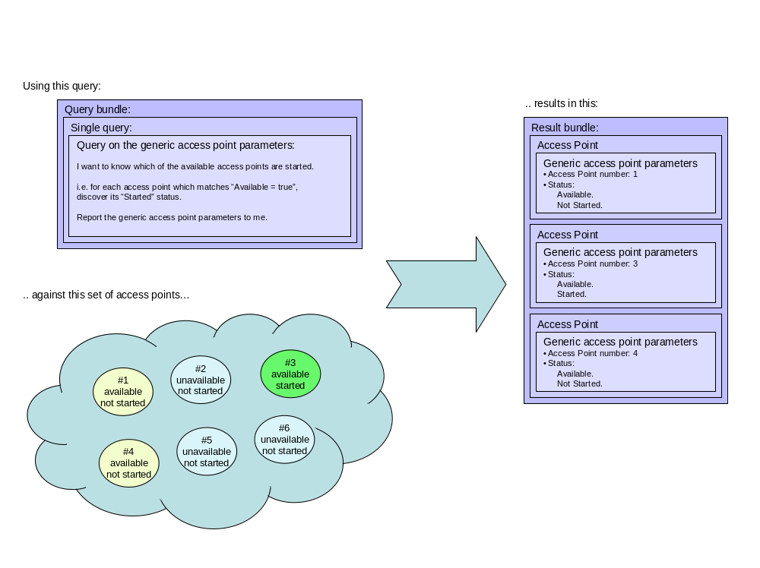
.. applying these concepts to the data structures required by the API, we get:
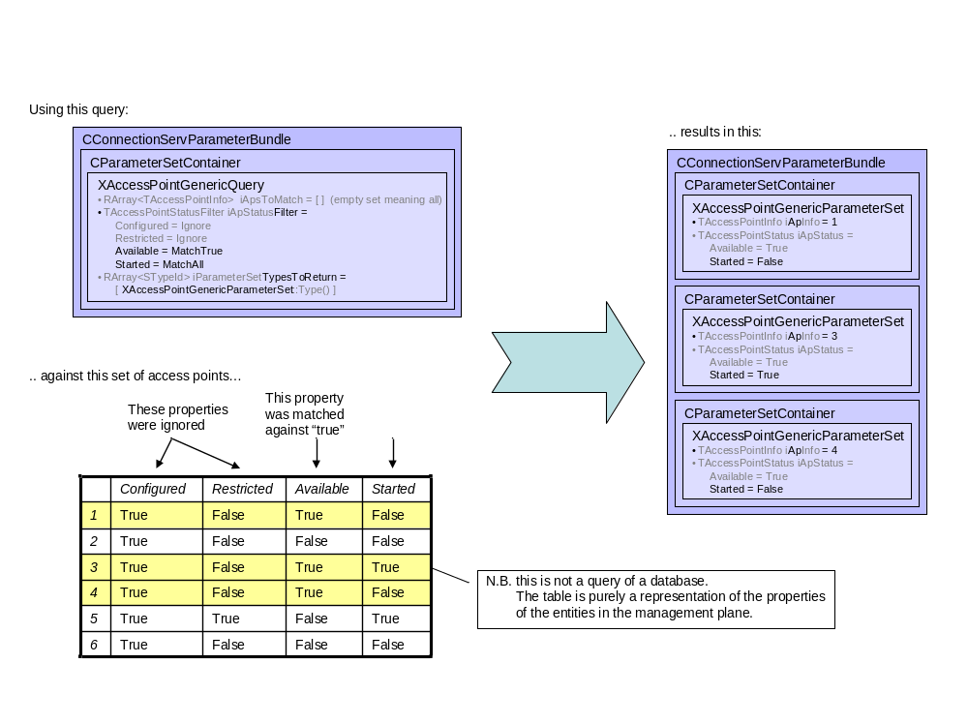

So, as code, to set up the query, we have:

iQueryBundle = CConnectionServParameterBundle::NewL();

TAccessPointStatusFilter availFilter;
availFilter.Configured(EAccessPointFlagIgnore);
availFilter.Available(EAccessPointFlagMatchTrue);
availFilter.Restricted(EAccessPointFlagIgnore);
availFilter.Started(EAccessPointFlagMatchAny);

// this helper function creates the necessary CParameterSetContainer
iQueryBundle->AddMatchConditionL(availFilter);

iQueryBundle->AddParameterSetToReturnL(
XAccessPointGenericParameterSet::Type());

iStatusBundle = CConnectionServParameterBundle::NewL();

// make call- the iStatus is a TRequestStatus owned by your active object
iConnServ.AccessPointStatusQuery(*iQueryBundle, *iStatusBundle, iStatus);

The state of the comms stack as shown in the diagrams above will result in your notification handler code to be called 3 times, once for each of the access point parameter sets returned - access point #1 (not started), #3 (started) and #4 (not started):

/*virtual*/
void CMyActiveObjectClass::RunL()
{
// some function to handle errors
MyErrorHandler(iStatus.Int());

// process results
CConnectionServParameterSetContainer* parSetCtr;
TInt i=0;
while(parSetCtr = iStatusBundle->GetParamSetContainer(i++))
{ // there will be 3 iterations – AP 1,3,4
XAccessPointGenericParameterSet* genParamSet =
XAccessPointGenericParameterSet::FindInParamSetContainer(parSetCtr);

if(!genParamSet) continue;
TUint apId = genParamSet->AccessPointInfo().AccessPoint();
TAccessPointStatus apStatus = genParamSet->AccessPointStatus();
TAccessPointFlagValue startedFlag =
genParamSet->AccessPointStatus().Configured();

/// Start: Your Handler
// then do whatever you need to do with the results:
if(startedFlag == EAccessPointFlagTrue)
{
My_MarkAsStarted(apId); // will run for AP 3
}
else if(startedFlag == EAccessPointFlagFalse)
{
My_MarkAsNotStarted(apId); // will run for AP 1,4
}
else // unknown
{
My_MarkAsUnknown(apId);
}
/// End: Your Handler
}
}

Access Point Change Notification

Example – when will this service become available?
Let’s say the user is interesting in monitoring a specific access point e.g. home wi-fi network, to see when it’s available via an icon on the phone’s display.
In this case the Access Point Id is known by a previous query, and much like the previous case a query bundle needs to be set up to tell the comms framework under which circumstances to notify.
The notification happens by the client code implementing MAccessPointNotificationObserver. This interface has a method AccessPointNotification which is called on each notification and a method AccessPointNotificationError which is called when there is a problem setting up or receiving notifications.

We open the session as above. Then:
// create bundle.. let’s say this is owned by this class so it is
// the destructor’s job to delete it..
iQueryBundle = CConnectionServParameterBundle::NewL();

// monitoring a specific access point
ASSERT(iKnownAccessPointId);

TAccessPointInfo apinfo;
apinfo.SetAccessPoint(iKnownAccessPointId);

// helper function to create basic query structure
// i.e. specification of the record to monitor for change
iQueryBundle->AddMatchConditionL(apinfo);

// specify the set of records which we're monitoring for change i.e.
// the situation in which we want to be notified
TAccessPointStatusFilter availFilter;

// a) notify on all changes to this field
availFilter.Available(EAccessPointFlagMatchTrue);

// b) don’t notify on changes to these fields
availFilter.Configured(EAccessPointFlagIgnore);
availFilter.Restricted(EAccessPointFlagIgnore);
availFilter.Started(EAccessPointFlagIgnore);

iQueryBundle->AddMatchConditionL(availFilter);

// helper function to specify what we want to get for each access point
iQueryBundle->AddParameterSetToReturnL(
XAccessPointGenericParameterSet::Type());

// start the notifications.. with this object as the handler
iConnServ.AccessPointNotification(*iQueryBundle,*this);

Somewhere else in the class we define the handler for notifications.
This will be called
- the first time with an empty bundle, once the notification handlers are all set up and ready. This tells you that you won’t miss any events from this point on, so you can make a status query to ensure you have a complete picture of the access point status that you’re interested in.. Only at this point can you safely delete your originally passed in query bundle.. then,
- subsequent times with a bundle containing the changed access points, every time an access point enters or leaves the set of access points defined by the query parameters, or in some other custom circumstances defined in a technology specific way in a particular ParameterSet-derived class.

/*virtual*/
void CMyClass::AccessPointNotification(
CConnectionServParameterBundle* aNotification)
{
// process results.
// only expecting 1 AP record back as only 1 AP was in the query
CConnectionServParameterSetContainer* parSetCtr
= aNotification->GetParamSetContainer(0);
ASSERT(parSetCtr); // very bad if nothing in bundle

XAccessPointGenericParameterSet* genParamSet =
XAccessPointGenericParameterSet::FindInParamSetContainer(parSetCtr);
ASSERT(genParamSet); // we asked for this set back so fatal if
// it’s not present in notification

TUint apId = genParamSet->AccessPointInfo().AccessPoint();
ASSERT(apId == iKnownAccessPointId);

TAccessPointStatus apStatus = genParamSet->AccessPointStatus();

if(apStatus.Available() == EAccessPointFlagTrue)
{
ChangeIconToAvailable(); // your handler function
}
else if(apStatus.Available() == EAccessPointFlagFalse)
{
ChangeIconToUnavailable();// your handler function
}

if(YouWantToStoreThisNotificationForLater())
{
iStoredNotifications.Append(aNotification);
}
else
{
delete aNotification;
}

if(BoredReceivingNotifications())
{
iConnServ->CancelAccessPointNotification();
}
}

Later, in some destructor/cleanup code, the bundles must be deleted:
delete iQueryBundle;
delete iStatusBundle;

Use Cases

Wi-fi
The user arrives in foreign airport, and wishes to access the internet on the device via wireless.

Initial scan
The browser on the phone needs to see which connections are available so it can present a choice to the user.
So a query is formulated to show available networks (both configured or not). Note this code is just an hypothetical example to show how the technology might be mapped to the ConnectionServ API. It is not representative of any specific wi-fi implementation by Symbian or any third party.

Headers to include:
#include <comms-infras/es_connectionserv.h>
#include <somewhere/wifi.h> // for KWiFiTierId
using namespace ConnectionServ;

In some setup function:

iConnServ.ConnectL(KWiFiTierId);

// create bundle
iQueryBundle = CConnectionServParameterBundle::NewL();

// set up the filter for our query
TAccessPointStatusFilter availFilter;

// a) either configured or not, tell us
availFilter.Configured(EAccessPointFlagMatchAny);

// b) don’t care- don’t even find this out
availFilter.Restricted(EAccessPointFlagIgnore);

// c) must be available in the air
availFilter.Available(EAccessPointFlagMatchTrue);

// d) may be connected already- find out
availFilter.Started(EAccessPointFlagMatchAny);

// helper function to create query structure
iQueryBundle->AddMatchConditionL(availFilter);

// helper function to specify what we want to get for each access point
iQueryBundle->AddParameterSetToReturnL(
XAccessPointGenericParameterSet::Type());
iQueryBundle->AddParameterSetToReturnL(
XAccessPointWiFiParameterSet::Type());

// N.B. XAccessPointWiFiParameterSet is not necessarily an existing class
// in Symbian OS- it is just shown here as an example of how such
// extension classes are used.

// create handle for result
iStatusBundle = CConnectionServParameterBundle::NewL();

// make call
iConnServ.AccessPointStatusQuery(*iQueryBundle, *iStatusBundle, iStatus);

Then in your active object’s RunL which runs on completion of the call:

/*virtual*/
void CMyActiveObjectClass::RunL()
{
// some function to handle errors
MyErrorHandler(iStatus.Int());

// process results
CConnectionServParameterSetContainer* parSetCtr;
TInt i=0;
while(parSetCtr = iStatusBundle->GetParamSetContainer(i++))
{
XAccessPointGenericParameterSet* genParamSet=
XAccessPointGenericParameterSet::FindInParamSetContainer(parSetCtr);
if(!genParamSet) {continue;}

TUint apId = genParamSet->AccessPointInfo().AccessPoint();
TAccessPointStatus availFlags = genParamSet->AccessPointStatus();

// retrieve technology specific extension
XAccessPointWiFiParameterSet *wiFiParamSet =
XAccessPointWiFiParameterSet::FindInParamSetContainer(parSetCtr);
if(!wiFiParamSet) {continue;}

TName ssid = wiFiParamSet->SSID();
TInt signalStrength = wiFiParamSet->SignalStrength();

// your handler for the retrieved information
AddToUserListDialogL(apId,availFlags,ssid,signalStrength);
}

Later, in some destructor/cleanup code, the bundles must be deleted:
delete iQueryBundle;
delete iStatusBundle;
iConnServ.Close();

Signal Strength Monitoring
Next the display app decides to monitor the signal strength of various wireless networks so the user can decide which is the best to use. As some of these networks may not yet be configured on the device it presents us with the problem that we need to refer to access points which don’t yet have an access point Id (as access point Id refers to an identification in the comms database).
As this is a more complicated query than the previous example we'll build the query structure ourselves rather than use one of the helper InitializeL() functions.
The query we formulate must use a wi-fi specific query extension in order to match SSID. The implementer of the technology may decide to provide helper functions to create the query data structure but for this example it’ll be shown explicitly as to aid understanding of what’s going on under the hood.
The query is formed of the following parameter sets:
- Generic parameter set: this defines the group of records- access points leaving or joining this group shall be reported as notifications
Availability parameters - defines the data sources for the access point information
Type IDs of the parameter sets that should be returned to us when notification occurs
- Technology-specific extension parameter set: group of access points to monitor
In this example, multiple SSIDs to monitor are held in the array iSSIDsToMonitor. This is a technology-specific match.

Set up wi fi connection server session as above, then:
iQueryBundle = CConnectionServParameterBundle::NewL();

// add parameter set container to bundle
CConnectionServParameterSetContainer* parSetCtr =
CConnectionServParameterSetContainer::NewL(iQueryBundle);

// we’ve added the container straight to the new bundle so pushing it onto
// the cleanup stack separately won’t be necessary

// define parameter sets to return for each AP notification – this time
// we’ll set it up explicitly instead of using the helper functions
XAccessPointGenericQueryParameterSet* genQueryParamSet =
XAccessPointGenericQueryParameterSet::NewL(parSetCtr);

// we’ve added the parameter set straight to the container in the existing
// bundle so pushing it onto the cleanup stack separately won’t be necessary

genQueryParamSet->AddParameterSetTypeToReturnL()
XAccessPointGenericParameterSet::Type());
genQueryParamSet->AddParameterSetTypeToReturnL()
XAccessPointWiFiParameterSet::Type());

// add wi-fi specific parameters to query record.
// this defines the group of APs we should watch
// N.B. XWiFiQueryMatchSSIDs is not necessarily an existing class
// in Symbian OS- it is just shown here as an example of how such
// extension classes are used.
XWiFiQueryMatchSSIDs* wifiQuery = XWiFiQueryMatchSSIDs::NewL(parSetCtr);
wifiQuery->SSIDs(iSSIDsToMonitor);

// tell the technology we want to monitor changes in signal strength
XWiFiQueryFieldsToMonitor* wifiQueryFieldsToMonitor =
XWiFiQueryFieldsToMonitor::NewL(parSetCtr);
wifiQueryFieldsToMonitor->MontitorSignalStrength(ETrue);

// start the notifications.. with this object as the handler
iConnServ.AccessPointNotification(*iQueryBundle, *this);

Somewhere else in the class we define the handler for notifications.

/*virtual*/
void CMyClass::AccessPointNotification(
CConnectionServParameterBundle* aNotification)
{
// process results
CConnectionServParameterSetContainer* parSetCtr;
TInt i=0;
while(parSetCtr = aNotification->GetParamSetContainer(i++))
{
XAccessPointGenericParameterSet* genParamSet =
XAccessPointGenericParameterSet::FindInParamSetContainer(parSetCtr);
if(!genParamSet) {continue;}
TUint apId = genParamSet->AccessPointInfo().AccessPoint();
TAccessPointStatus apStatus = genParamSet->AccessPointStatus();

XAccessPointWiFiParameterSet* wiFiParamSet =
XAccessPointWiFiParameterSet::FindInParamSetContainer(parSetCtr);
if(!wiFiParamSet) {continue;}
TName ssid = wiFiParamSet->SSID();
TInt signalStrength = wiFiParamSet->SignalStrength();

// some function to process result
UpdateUserListDialog(apId,apStatus,ssid,signalStrength);
}
}

Clean up as before.

Bluetooth
The user wishes to access the internet using a Bluetooth PAN configuration. This is much like the wi-fi case in that many possible devices may be available to connect to. Only some of them will support the PAN profile, and only some of them will have sufficient login credentials stored on the device to connect to them.

Converged Comms
This is the extrapolation of the idea of availability to application layer protocols. For example, the availability of an instant messaging service, or the availability of an email service.
Knowing this is beyond just knowing that the underlying IP connection is available, it's also a case of knowing the remote server is responding, and that the login credentials stored on the device are confirmed by the remote server.

Legacy support
As RConnection primarily exists to represent a single connection its many-connection-oriented functions such as AllInterfaceNotification and EnumerateConnections have been deprecated and legacy support has been implemented in terms of Connection Server.

AllInterfaceNotification
This is equivalent to connecting to the link tier and receiving notifications of all changes to the availability flag.

EnumerateConnections
This is equivalent to connecting to the IP proto tier and performing an access point query, then counting the number of returned access points (the number of families in the returned result bundle).

Further Information
The following section should always be the last section of the document as it is essentially information about the document rather than its content.

People
Role | Person / People
Reviewers | Barry Alcock
Contributors | Rob Lundie
Distribution | Licensees, or software engineers using or maintaining code for the Connection Server

References
No. | Document Reference | Version | Description
[R1]
[R2]

Open Issues

Glossary
Term | Definition

Document History
Date | Version | Status | Author | Description
28-08-2008 | 1.0 | Issued | Rober Lundie | Updated and changes for review comments made
18-09-2006 | 0.1 | Draft | Robert Lundie | First draft based on SGL.PPS001.500 Lightweight Document Template Rev 8.6

